Archiving and Compression

tar -cf backup.tar /home/user/documents

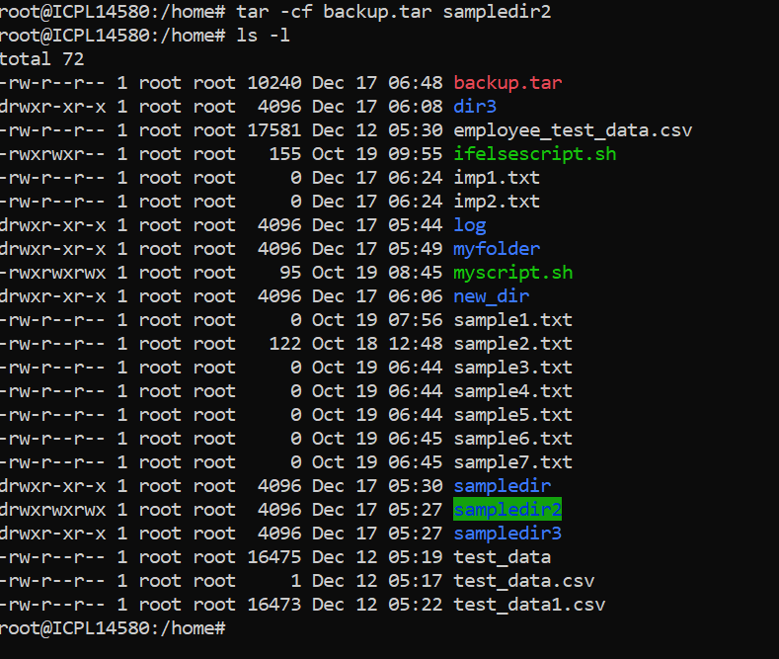

tar -xf backup.tar

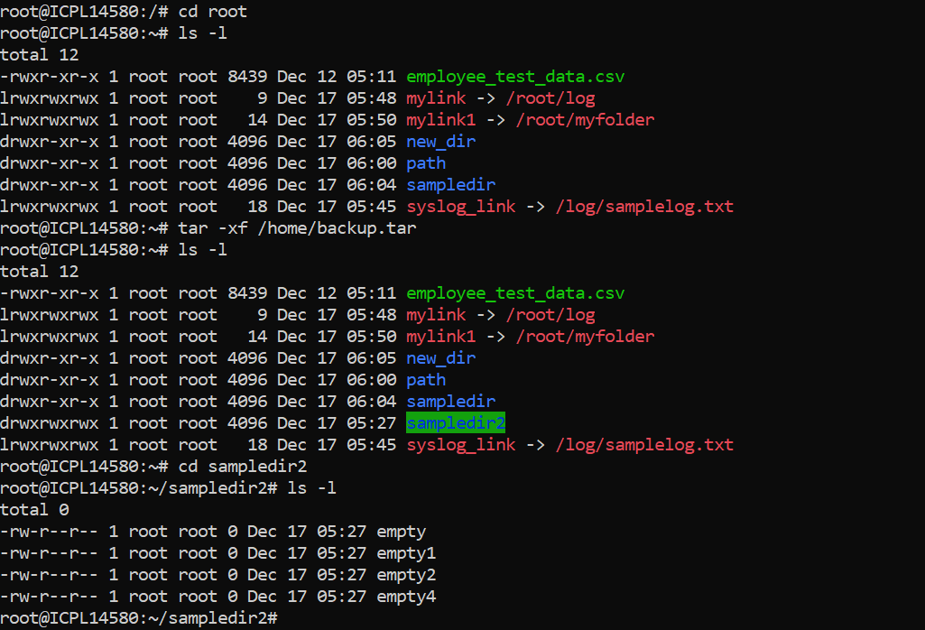

gzip file.txt

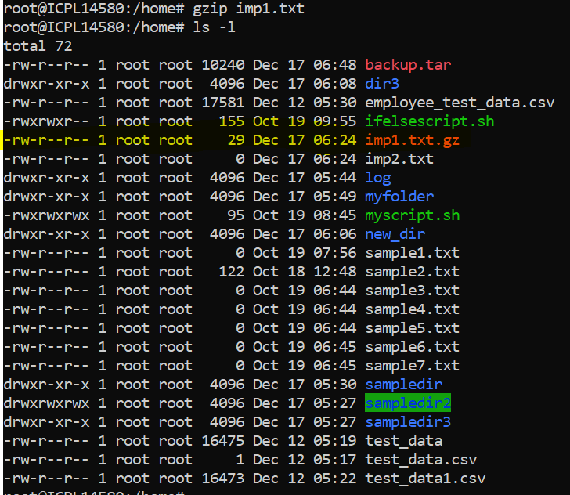

gunzip file.txt.gz

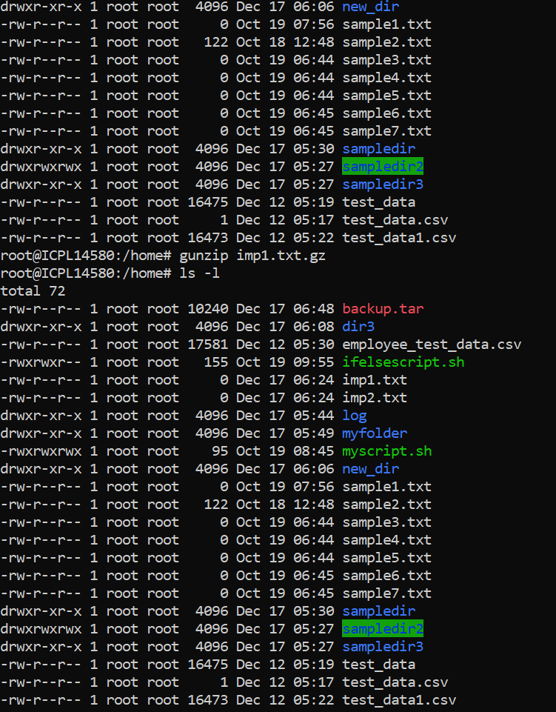

zip archive.zip file1.txt file2.txt

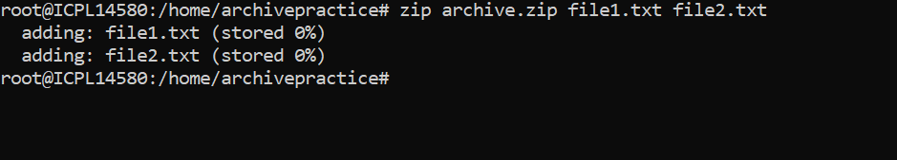

unzip archive.zip

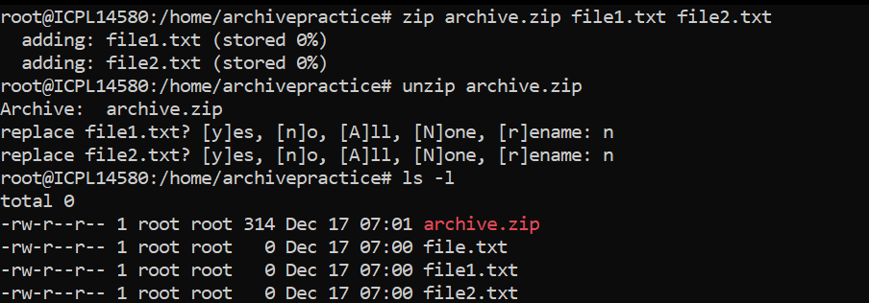

xz largefile

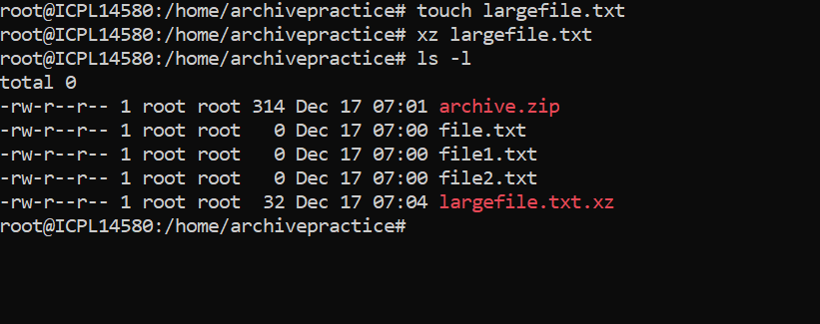

unxz largefile.xz

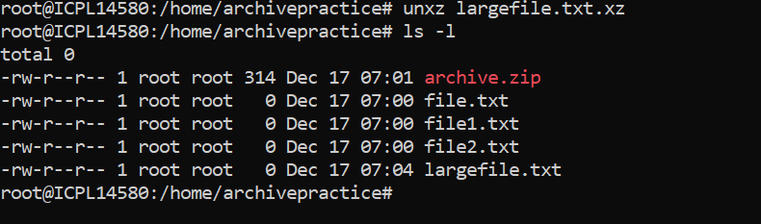

tar -czf backup.tar.gz /var/log

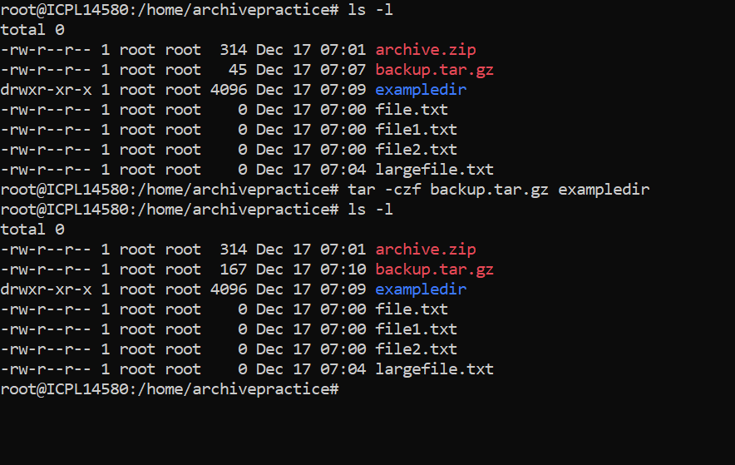

tar -xzf backup.tar.gz

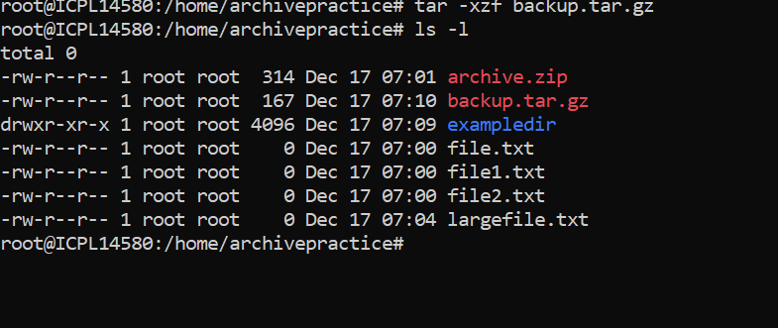

zip -r project.zip /home/user/project

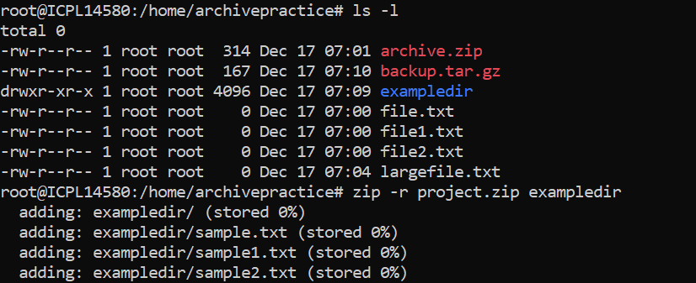

xz log1.log log2.log

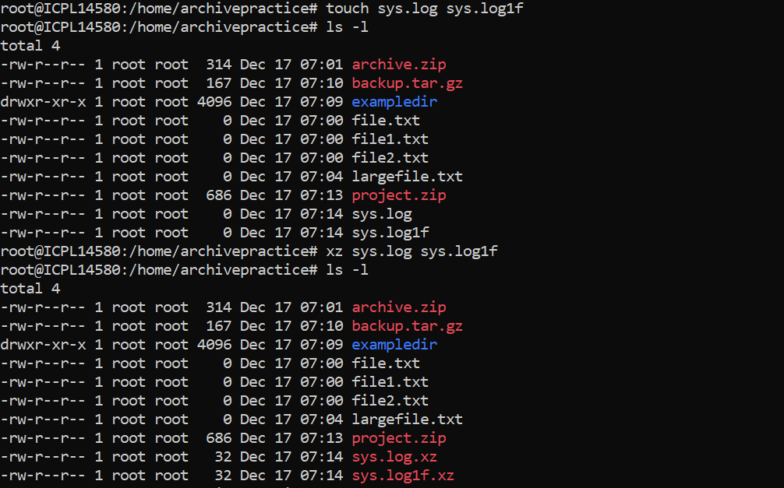

tar -xzf backup.tar.gz file1 file2

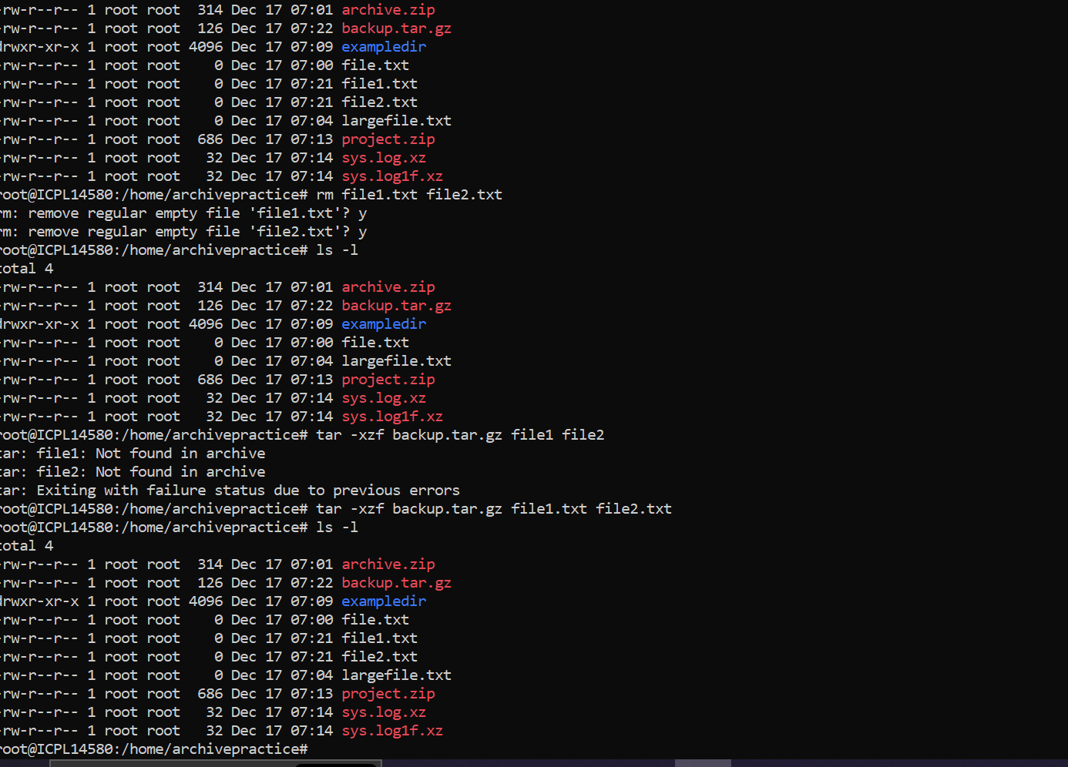

To sync and compress files for remote backup using rsync and gzip

rsync -avz /source/path/ user@remote:/destination/path/

The -z flag compresses data during transfer, saving bandwidth.